

SRI LANKA INSTITUTE OF INFORMATION TECHNOLOGY

[**Enterprise Standards and Best Practices for IT Infrastructure**](http://courseweb.sliit.lk/course/view.php?id=137)

**4th Year 2nd Semester 2016**

Name: Reyhart D.S.A

SLIIT ID: IT13064082

Practical Session: WE Monday

Practical Number: Lab 4

Date of Submission: 01-08-2016

Date of Evaluation : _____________________

Evaluators Signature : _____________________

**Lab 04 - Baremetal Virtual machine Installation**

1. Create a new virtual machine.

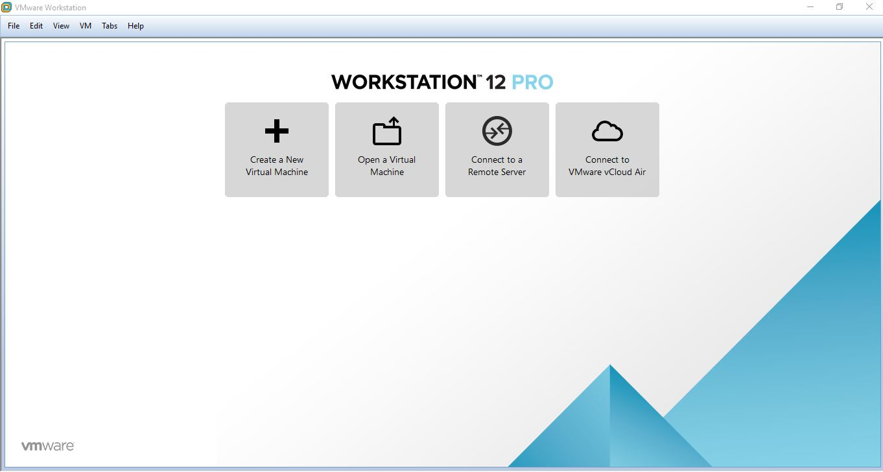

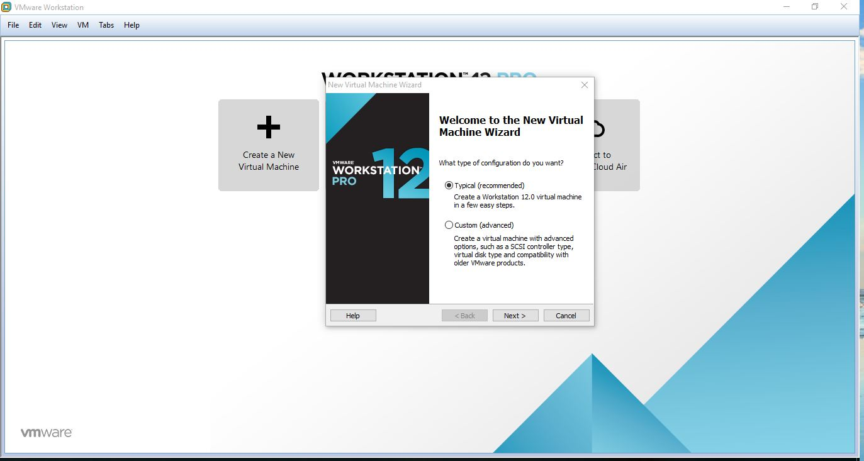2. Select Typical and press next.

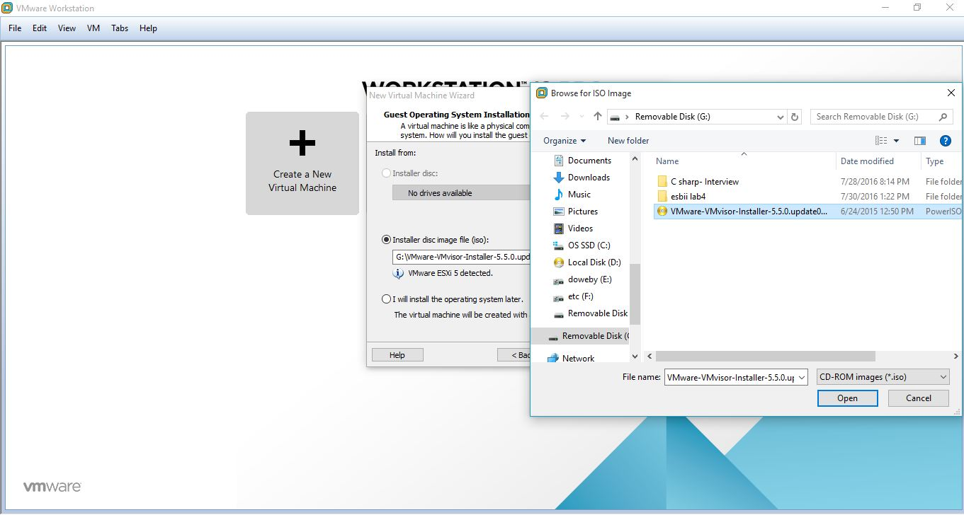3. Then select installer disc image file and browse the image file location.

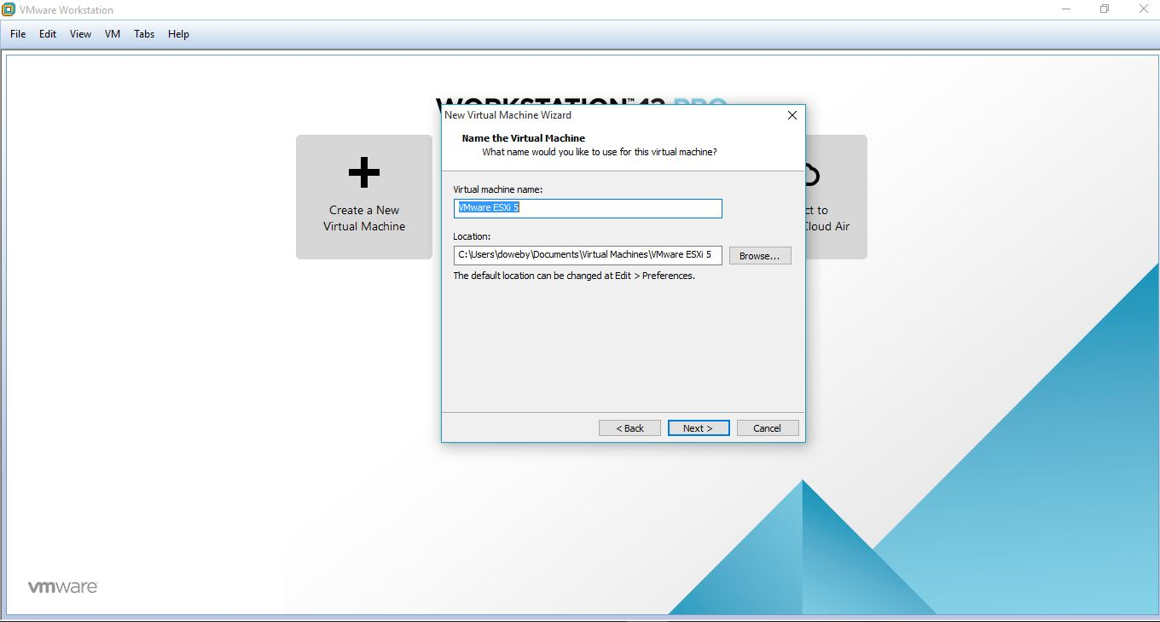4. Then browse a place to save the virtual machine.

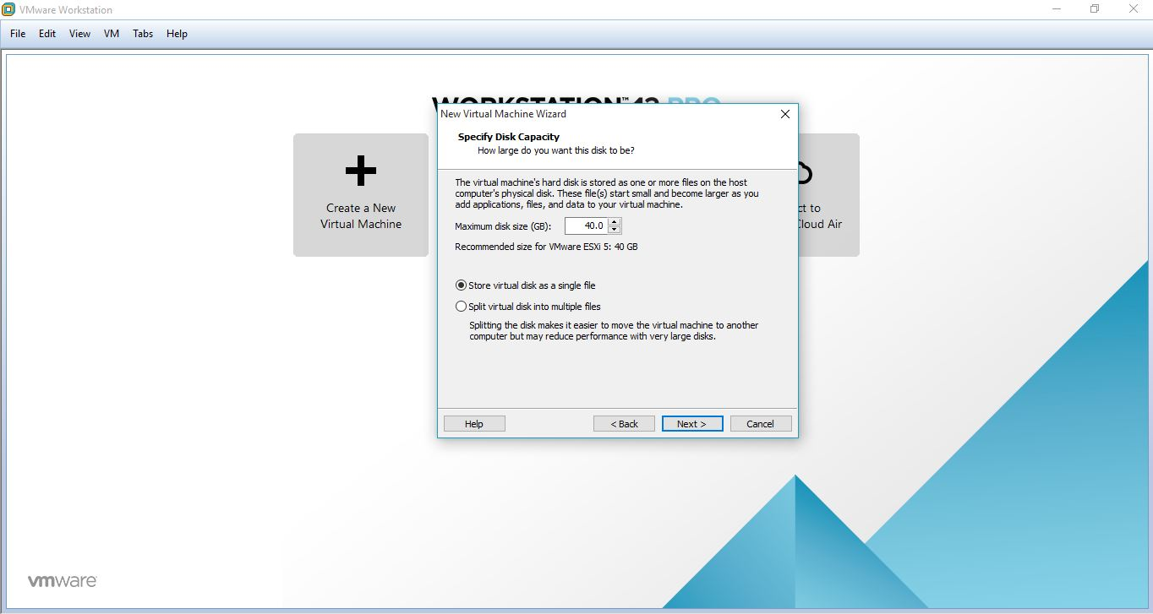5. Select the size for the virtual machine.

6. Then press Finish.

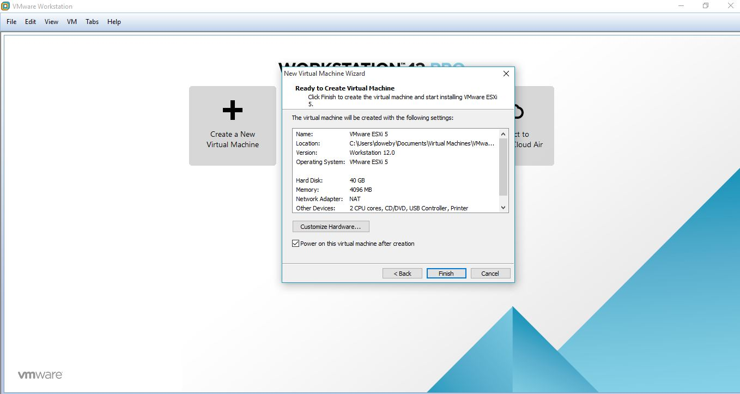

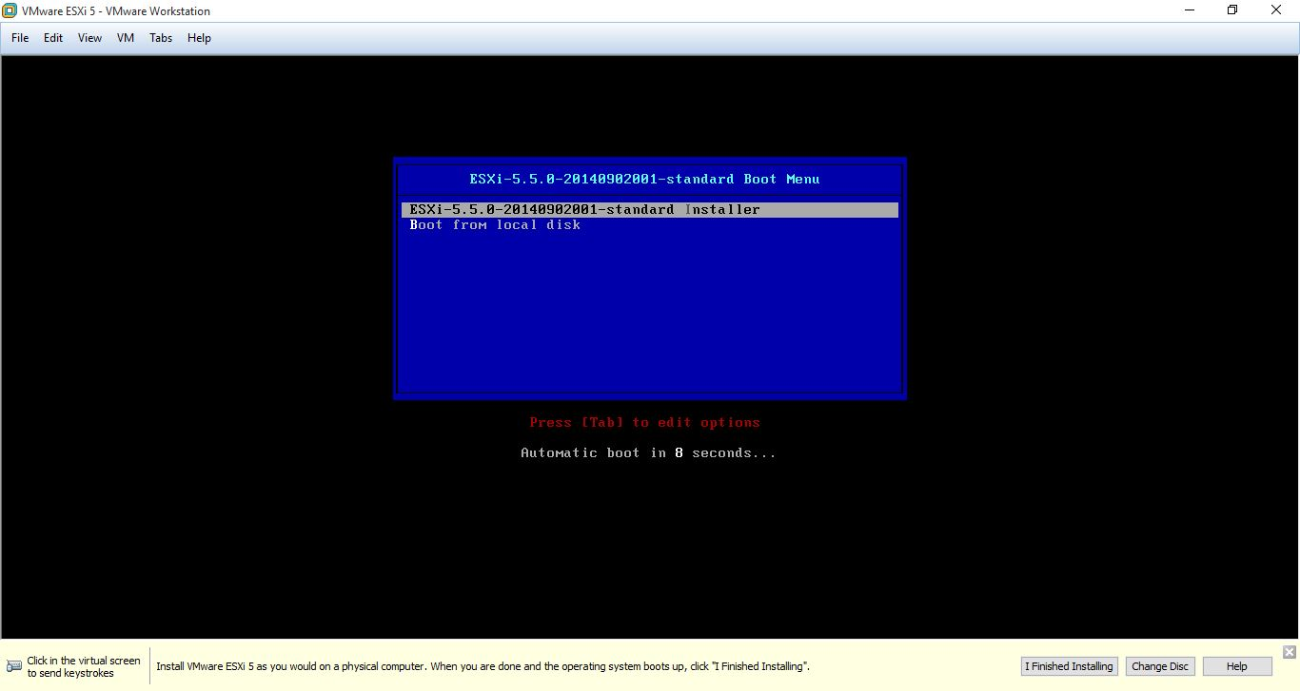7. Then ESXI-5 will start booting.

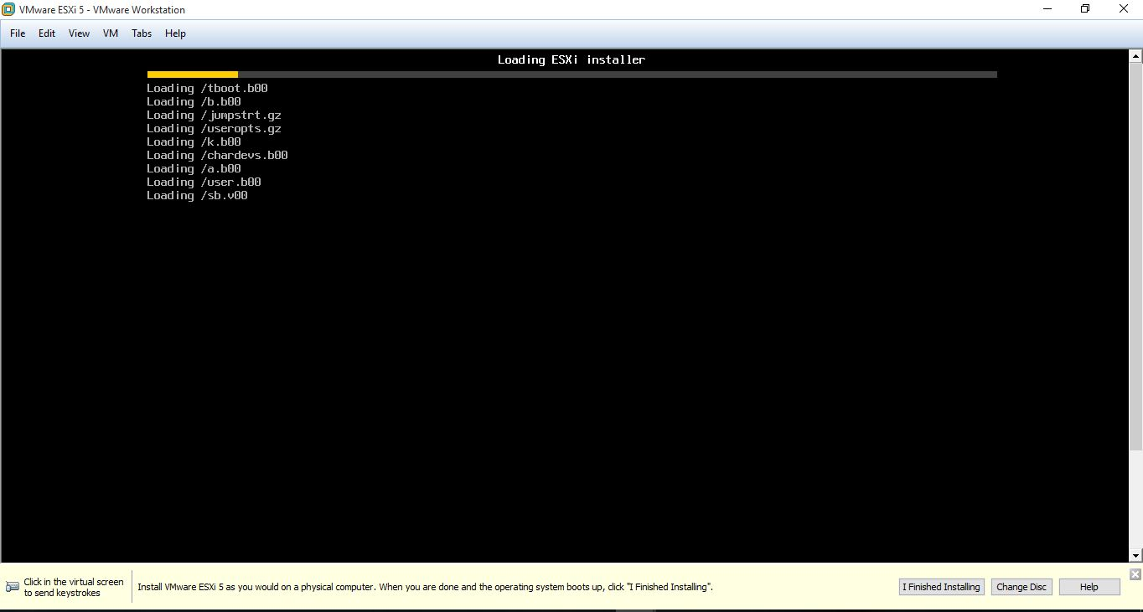8. Wait until EXSI installer Loads.

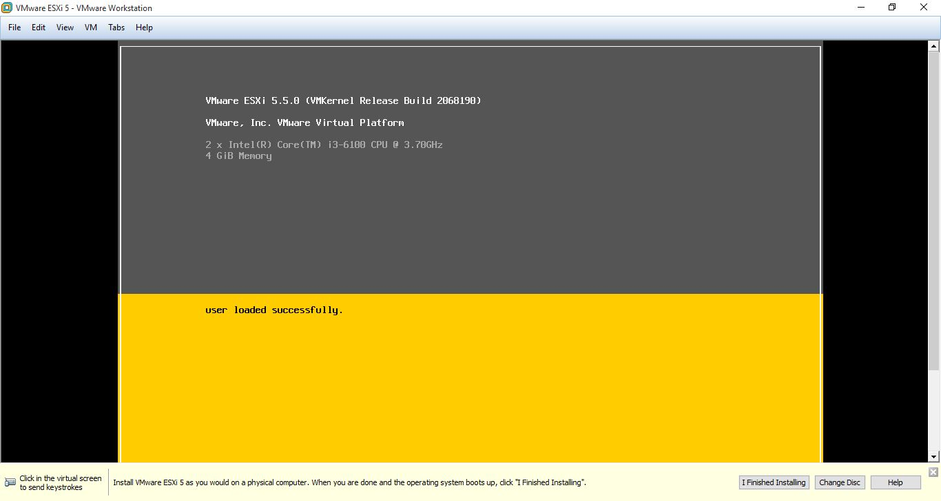9. Loaded

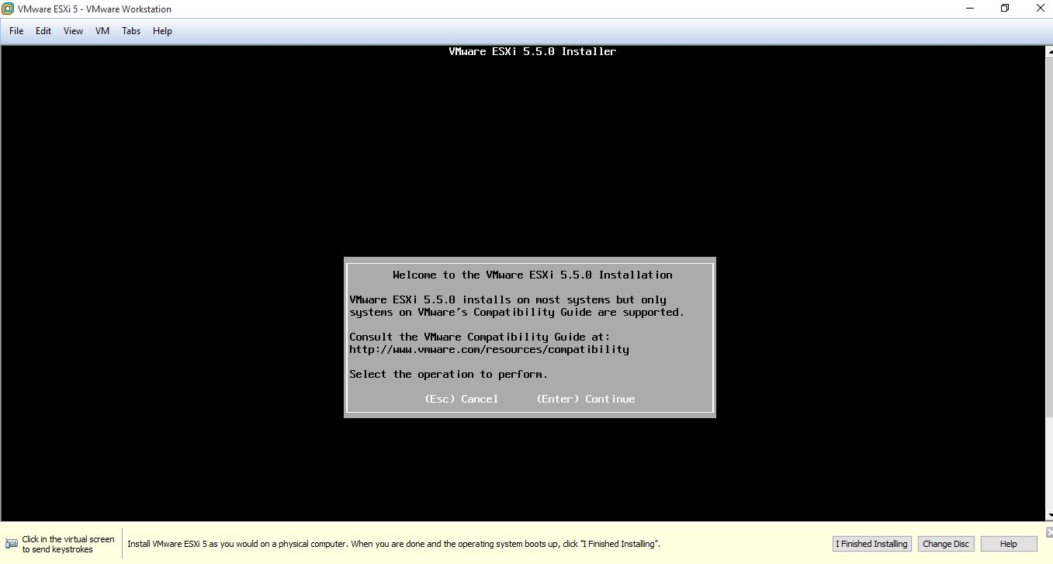10. Press Enter to continue.

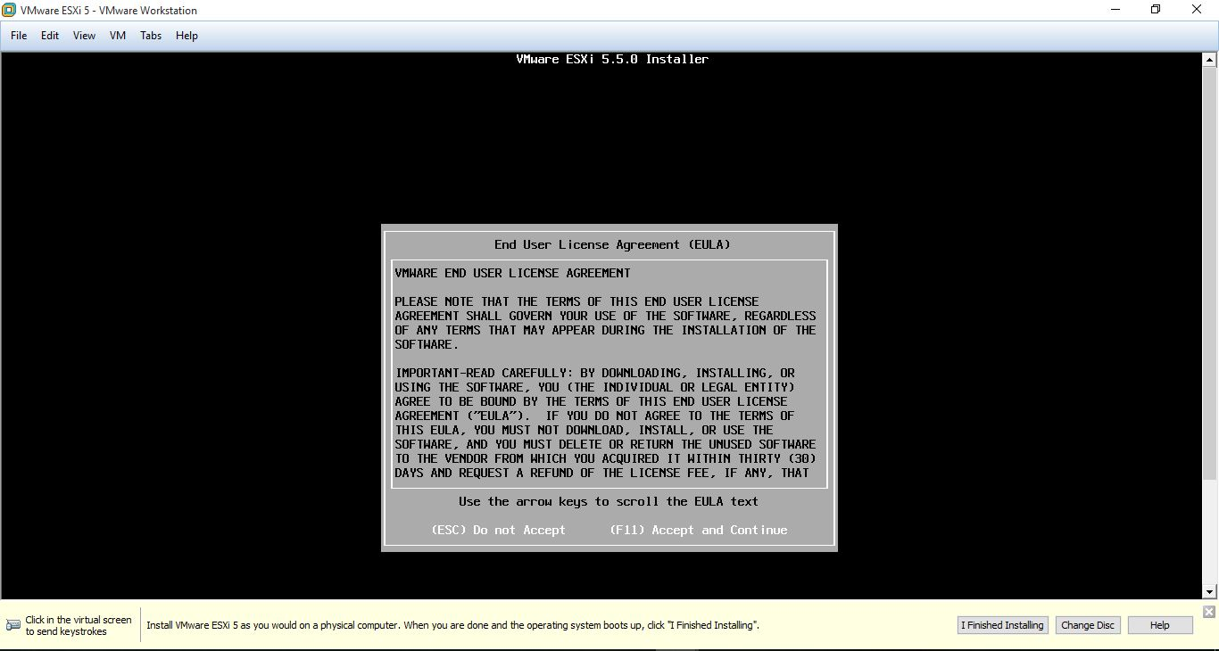11. Press F11 to accept and continue.

12. Press Enter to continue.

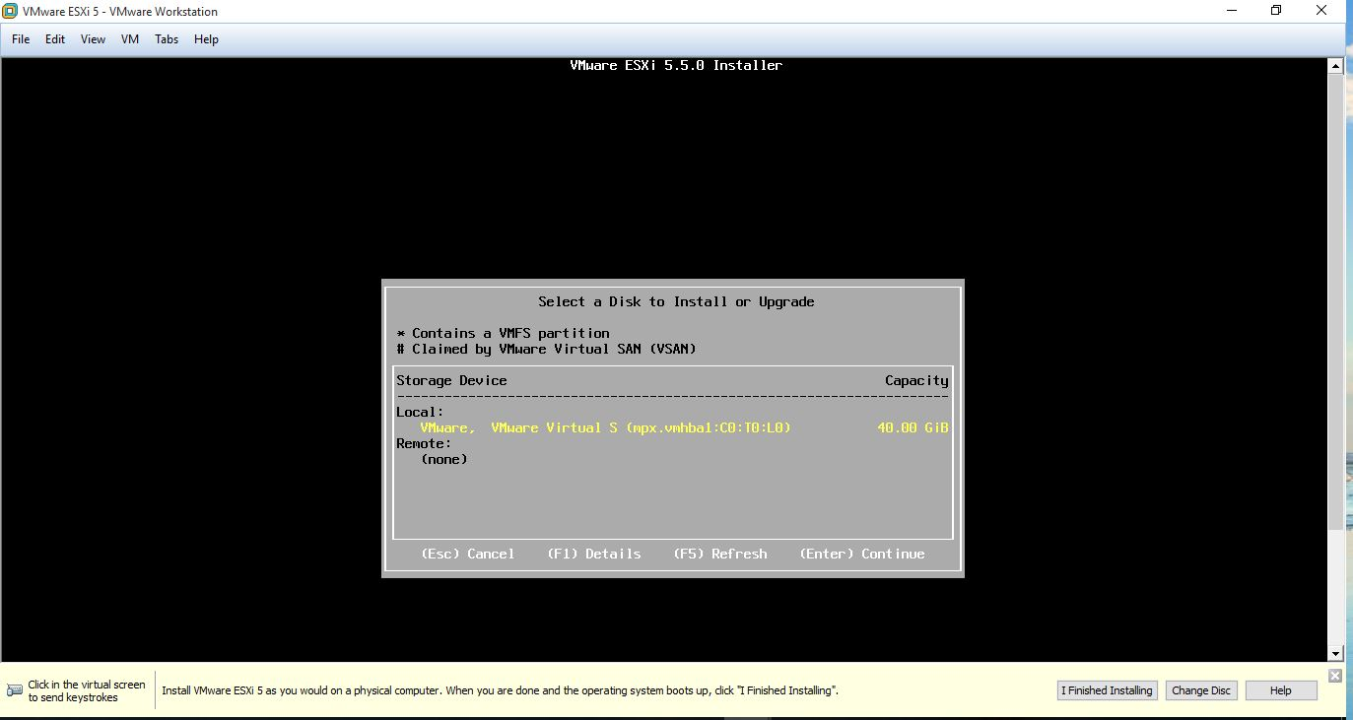

13. Choose keyboard layout as default and press enter.

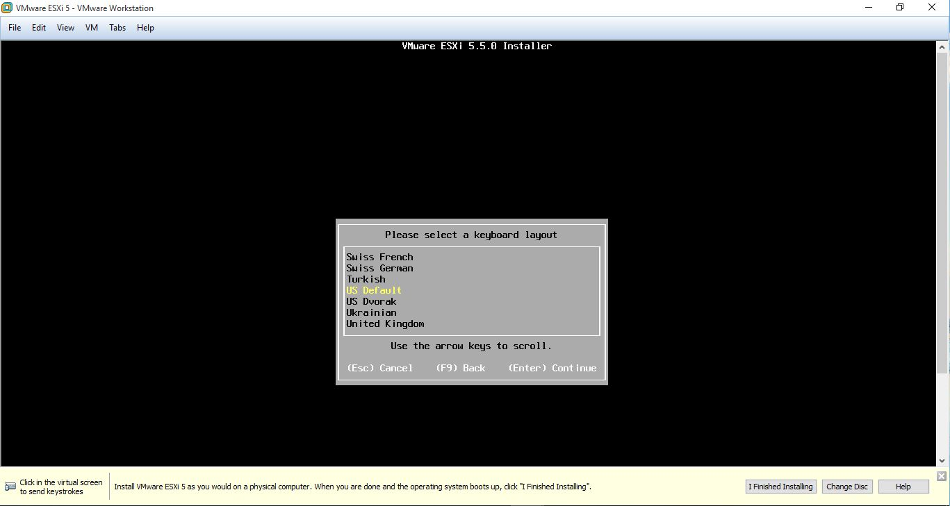

14. Enter a password which more than 7 letters and confirm it.

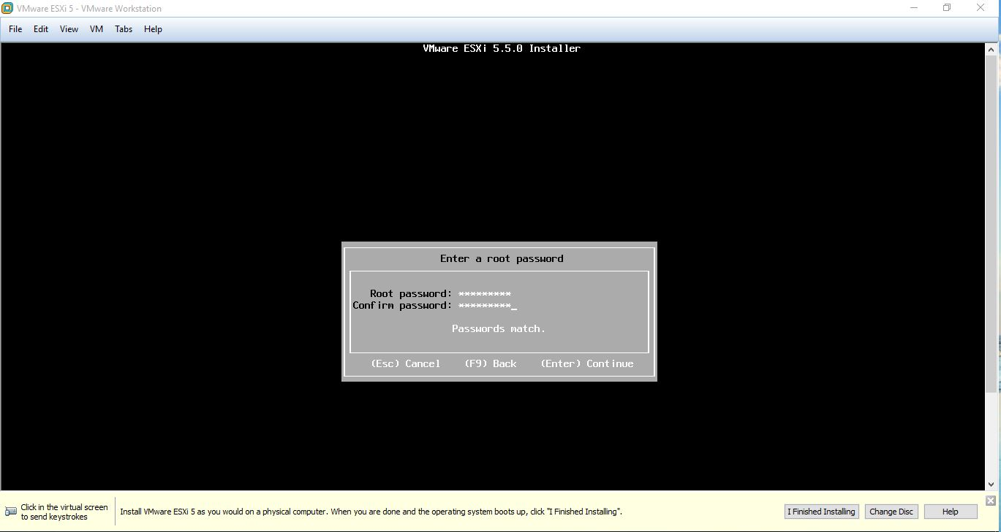

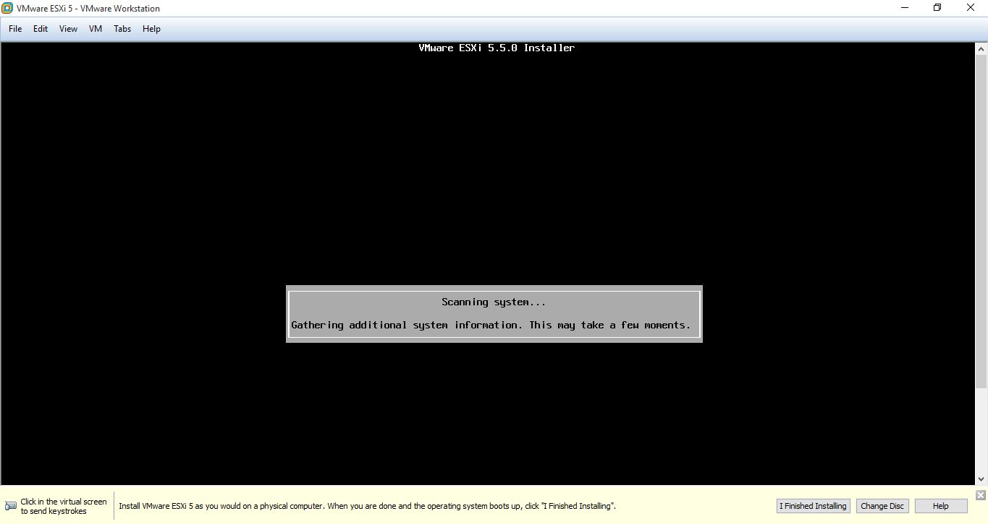15. Then system scanning will appear.

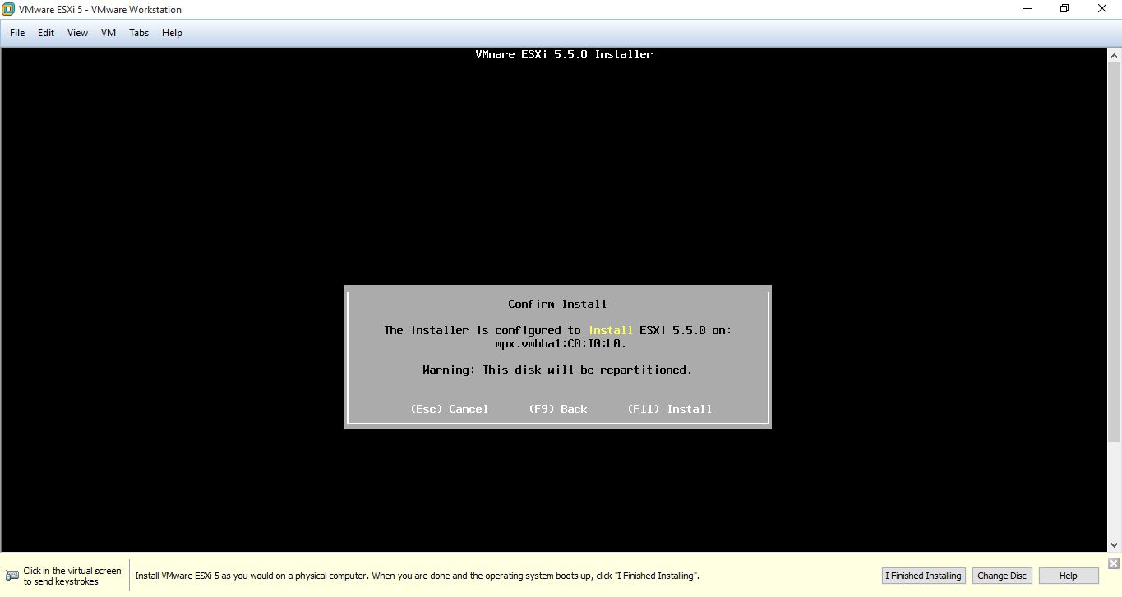16. Then confirm the installation of ESXi by clicking F11.

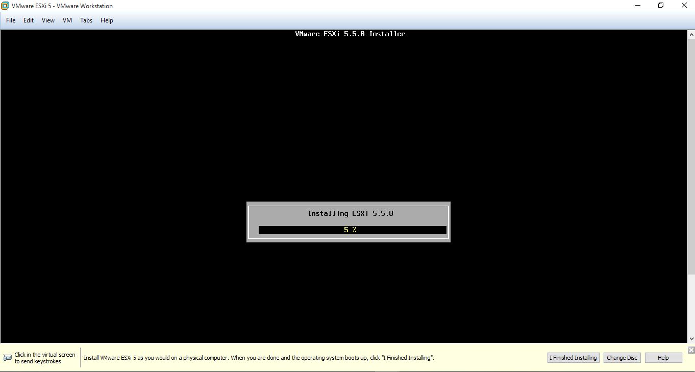17. Installing ESXi.

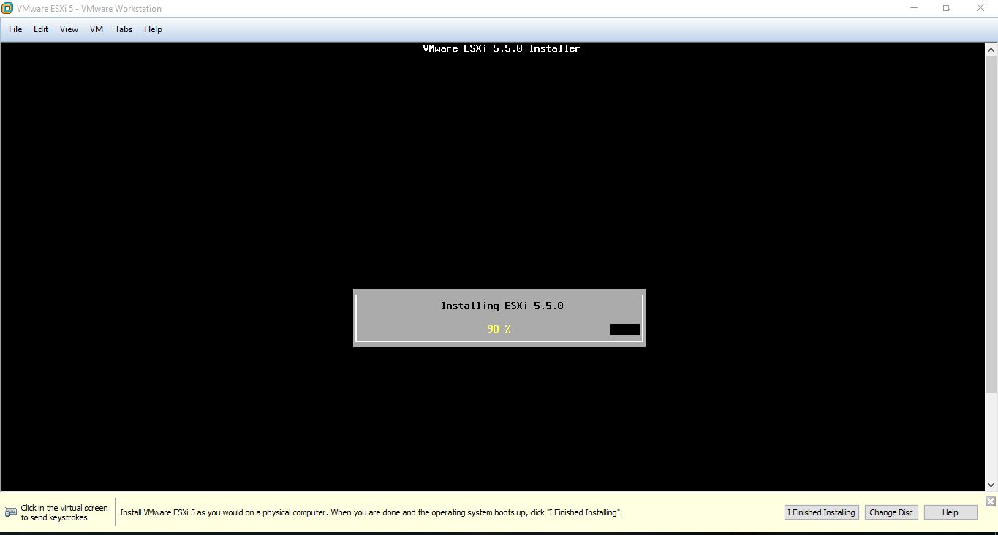

18. Now installation is complete. So press Enter to Reboot.

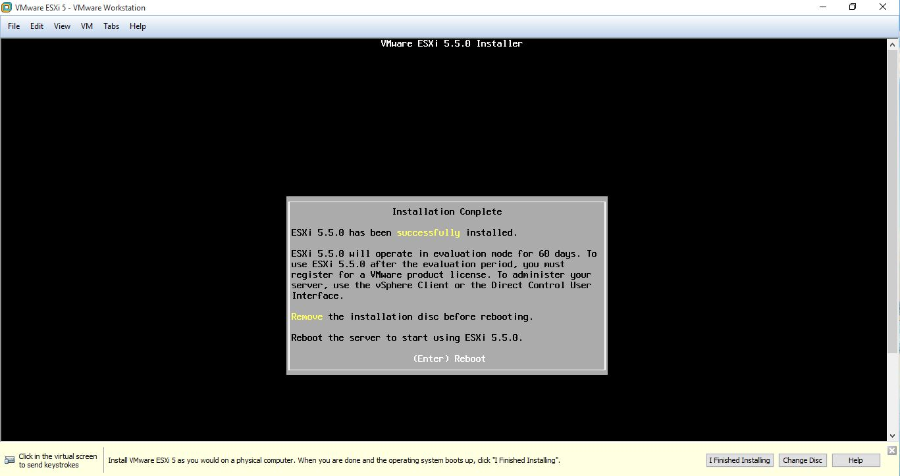

19. Rebooting the server.

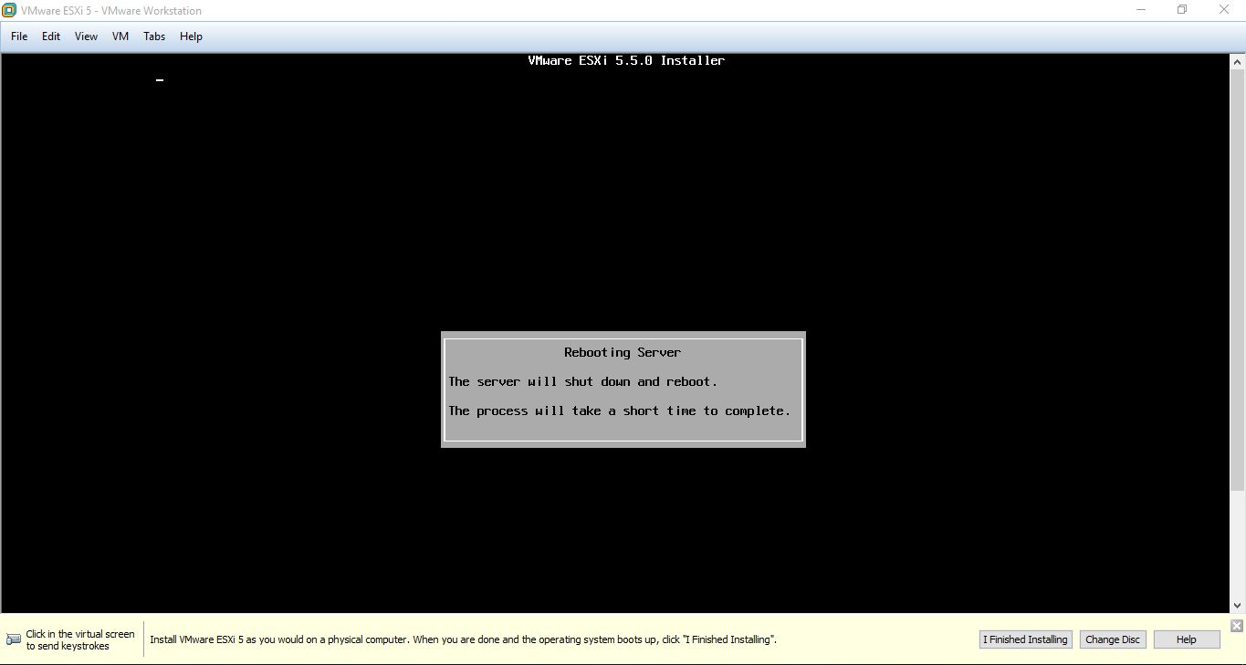

20. Loading VMware ESXi after the reboot.

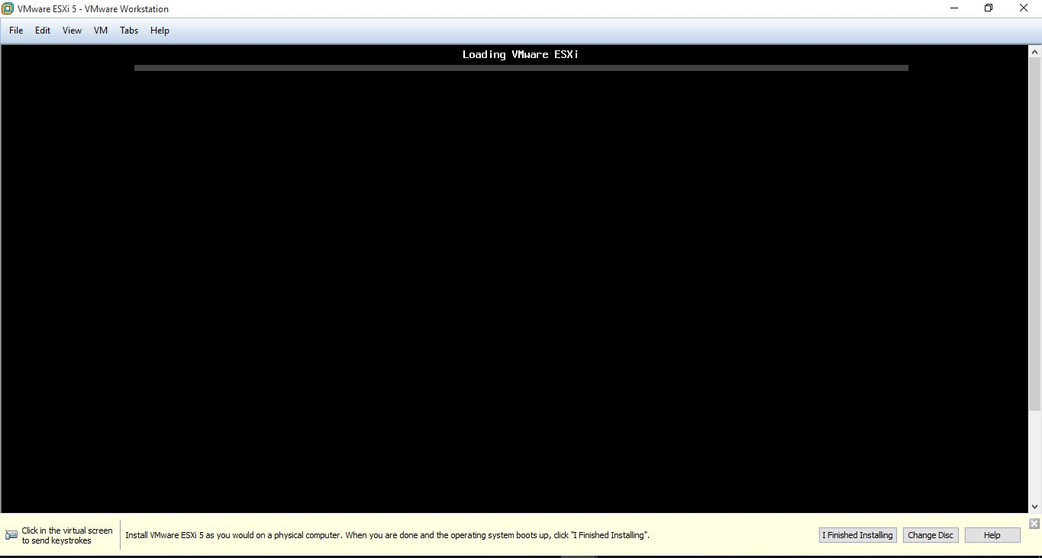

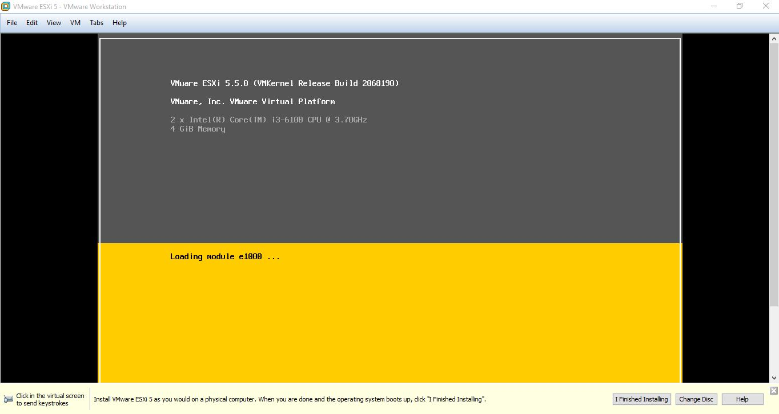

21. Downloading the vSphere Client.

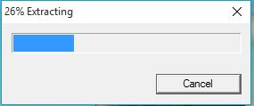

22. Select the language.

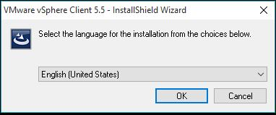

23. Installing the vSphere Client.

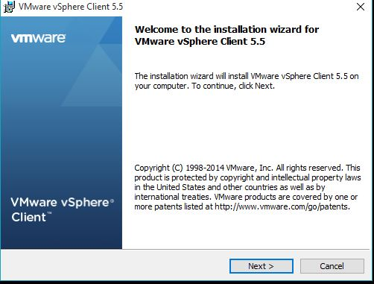

24. Press Install.

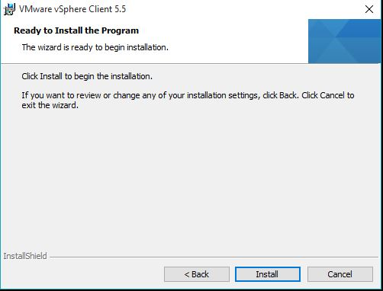

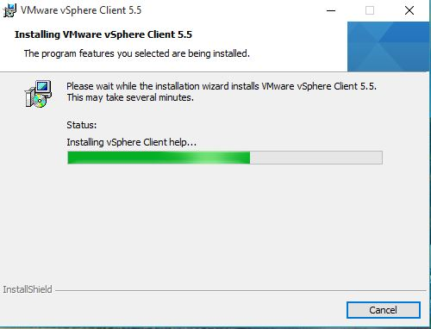

25. To complete the installation press Finish.

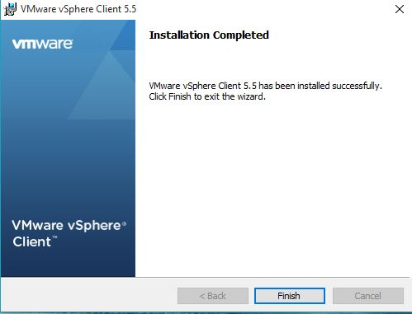

26. Then to go inside vSphere give IP address of VMware ESXi and under the username of root give a password.

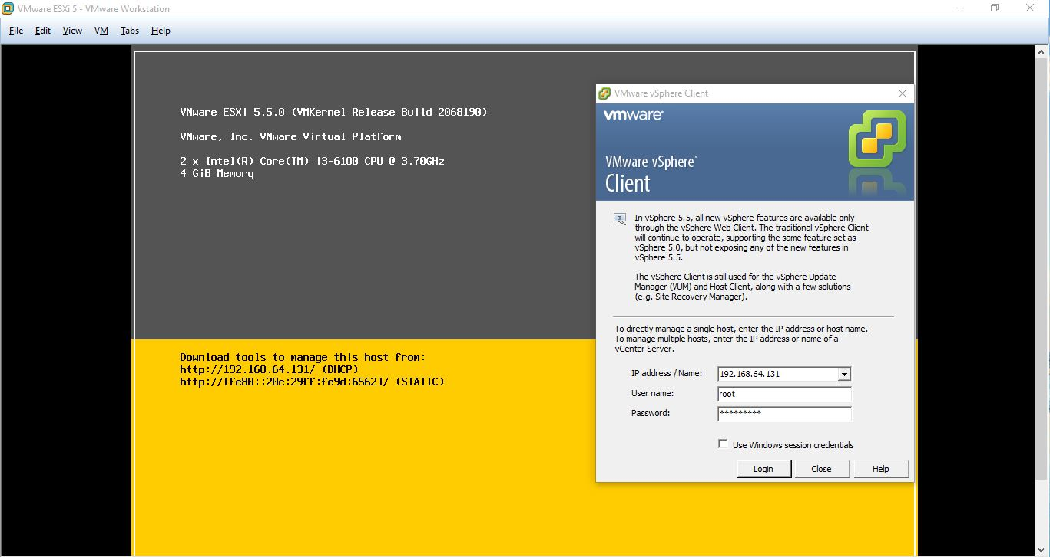

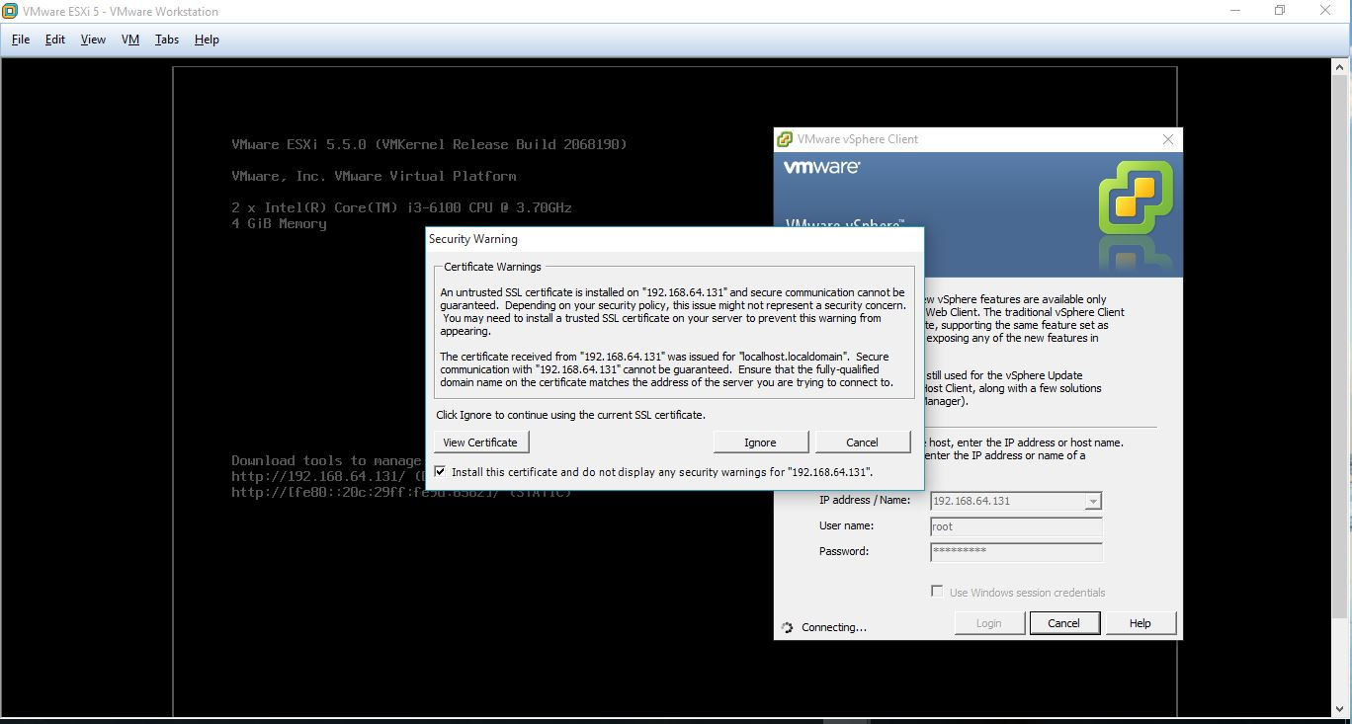27. Press Ignore.

28. Then vSphere interface will appear.

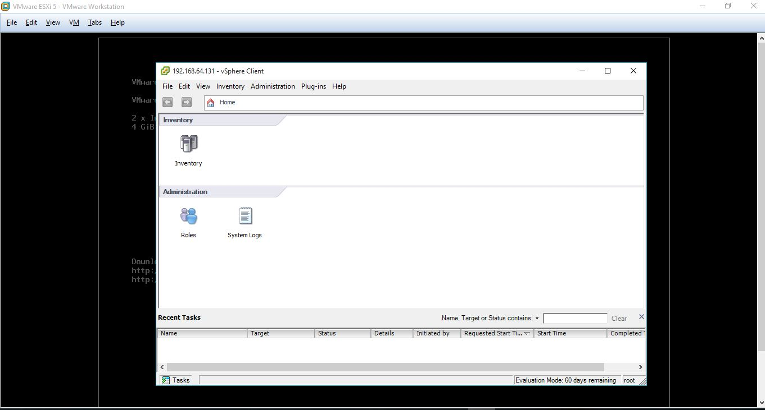

29. Then go to summary tab.

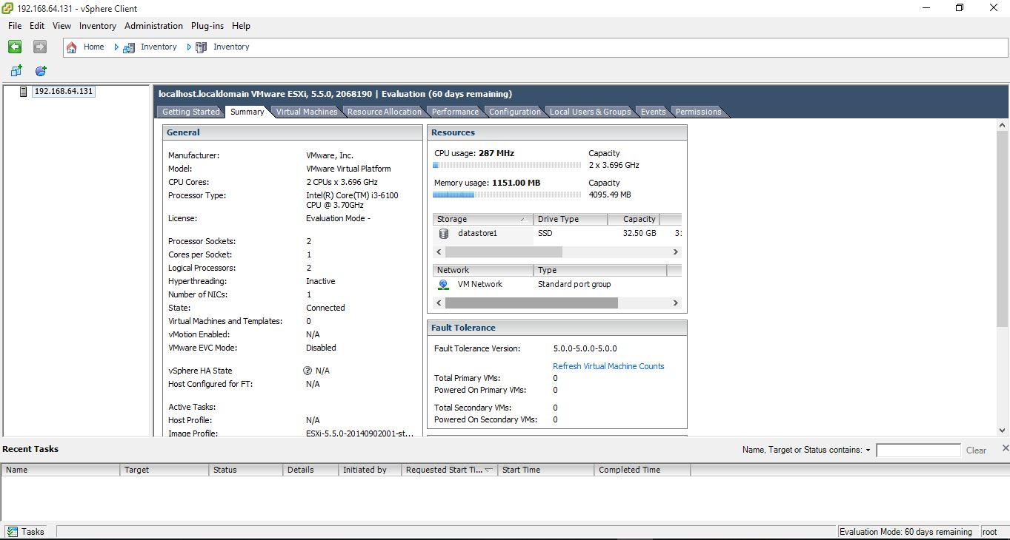

30. Under Storage Database, browse a database.

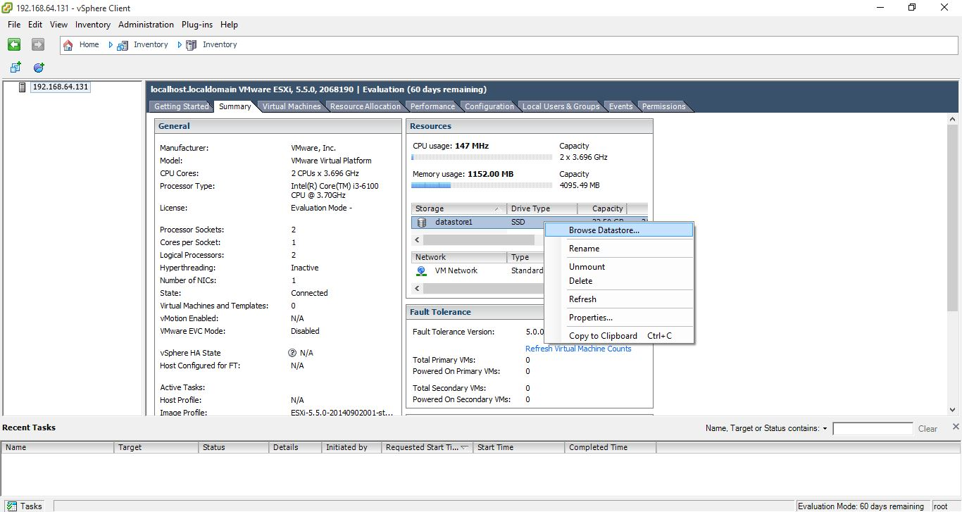

31. Select Upload File.

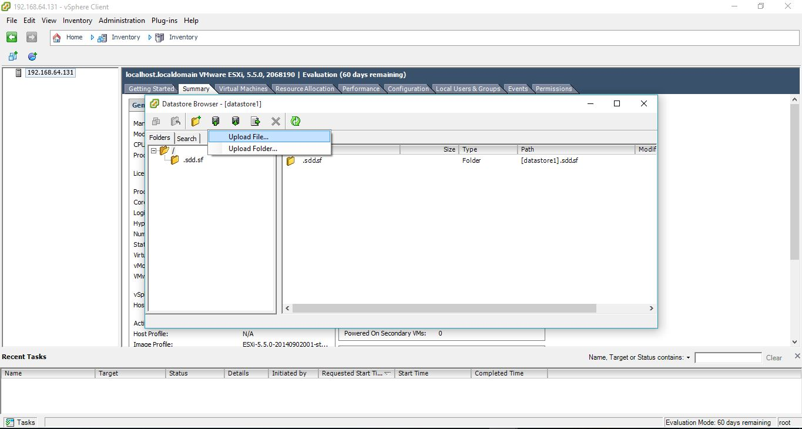

32. Upload a database.

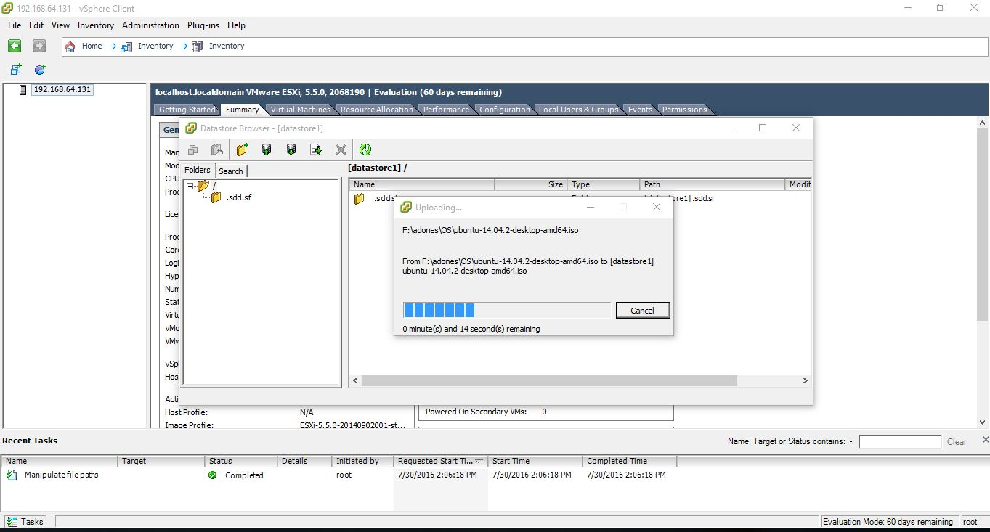

33. Database Uploaded.

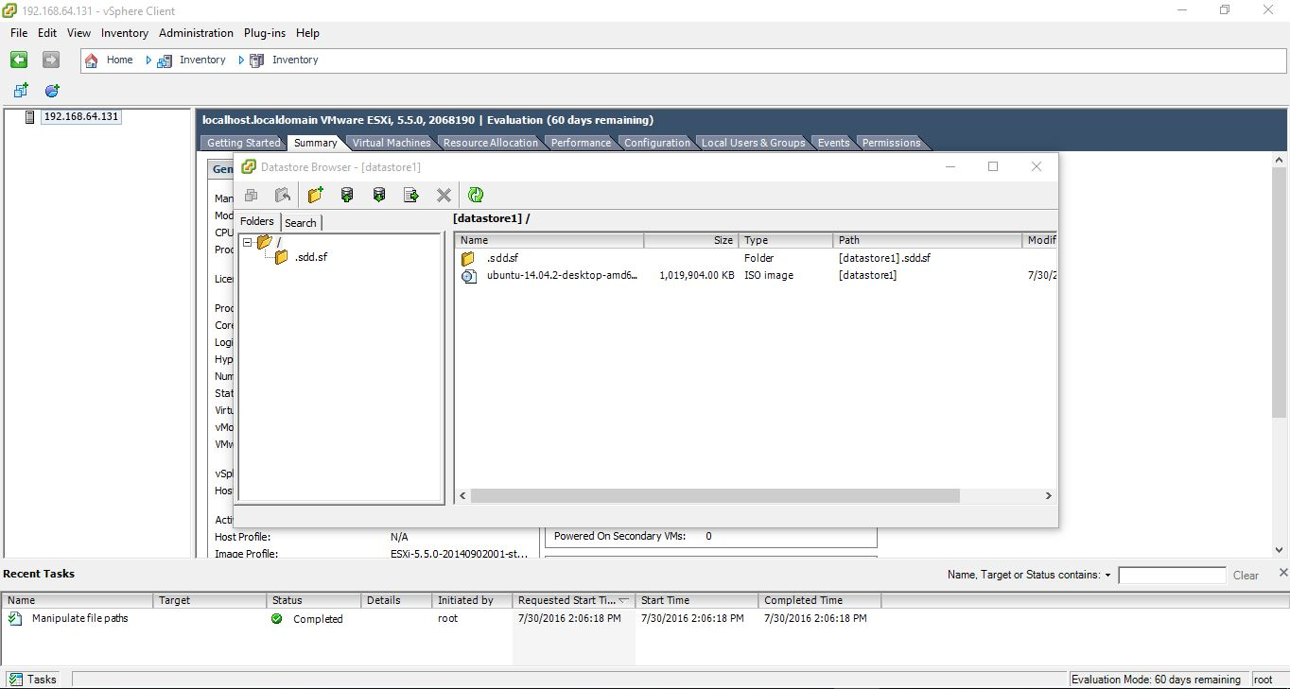

34. Right click on the ip address and choose New Virtual Machine.

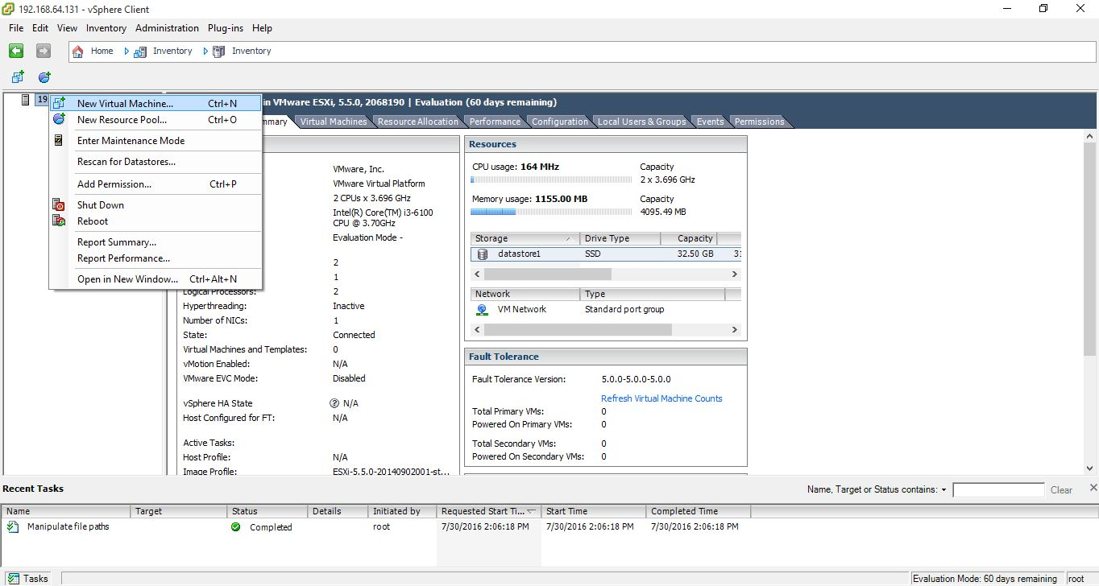

35. Select Typical and select Next.

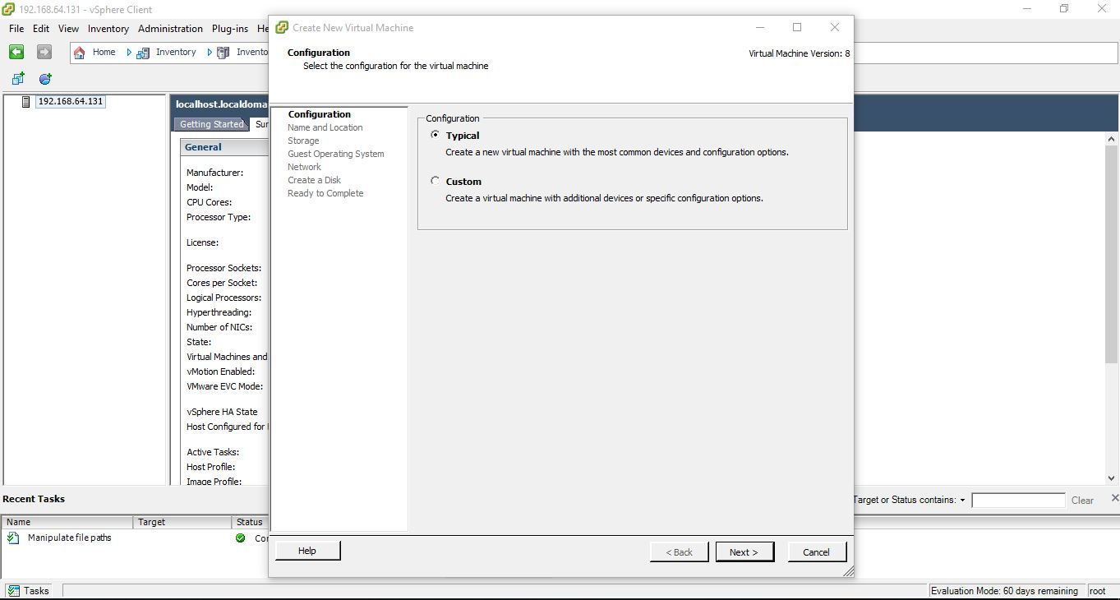

36. Give a name to the virtual machine.

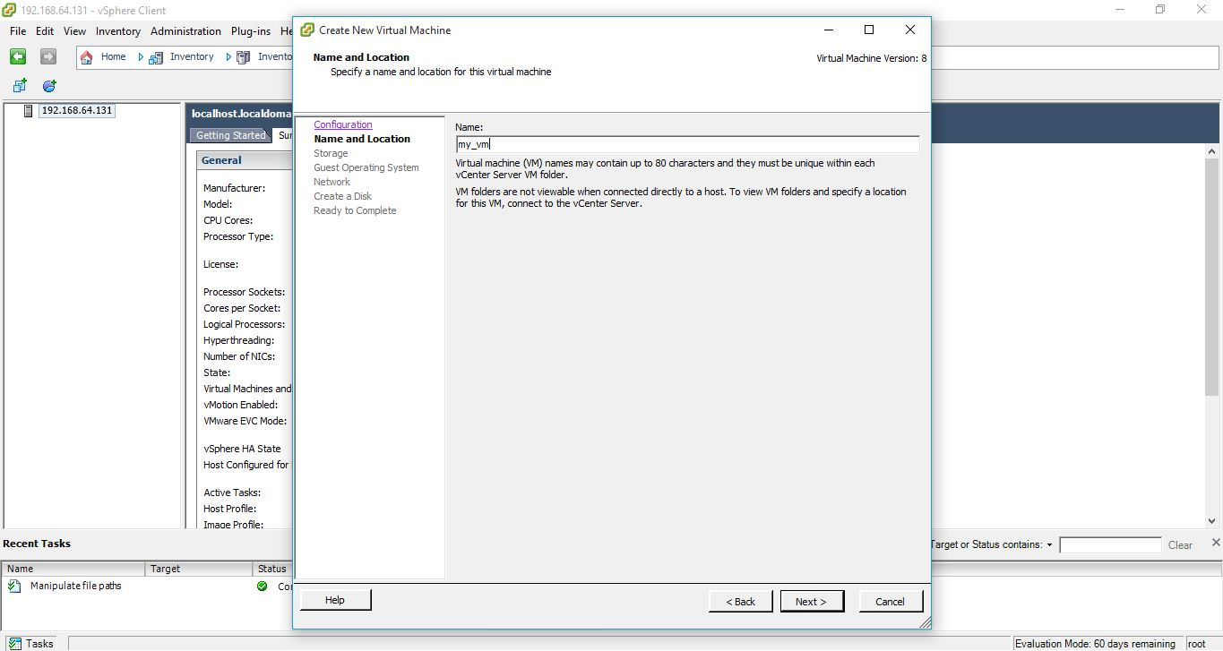

37. Select Operation System Type and version.

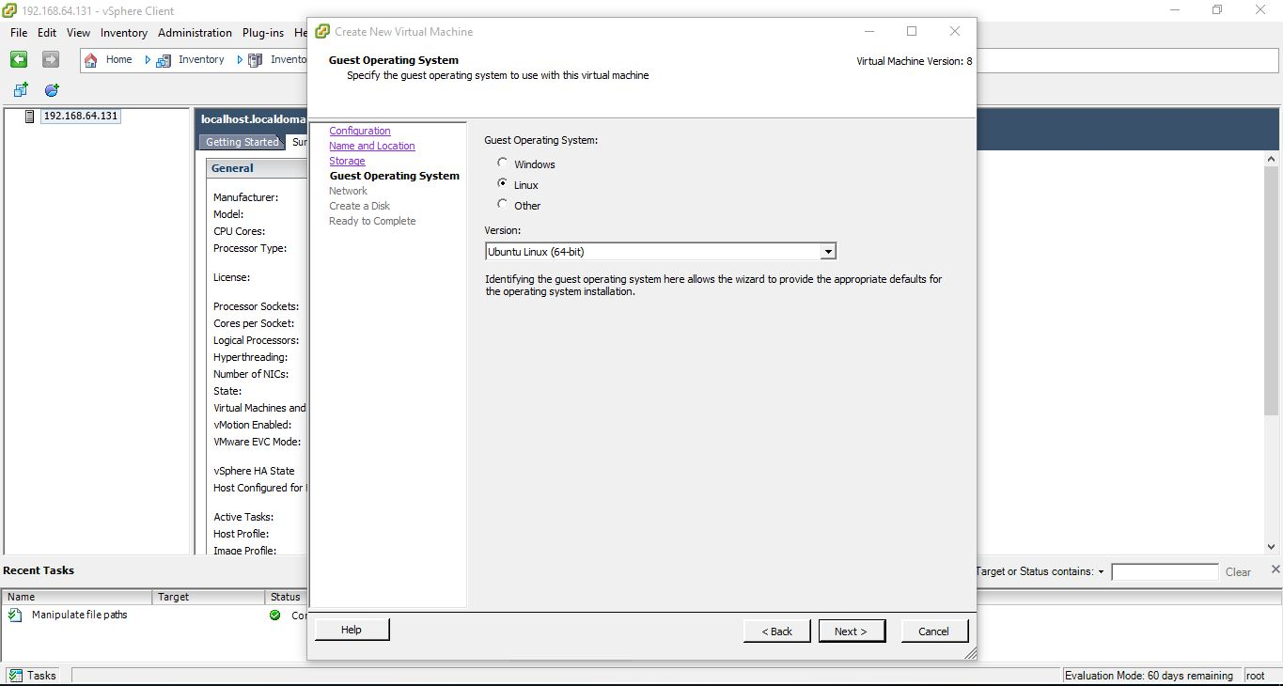

38. Select Adapter as E1000.

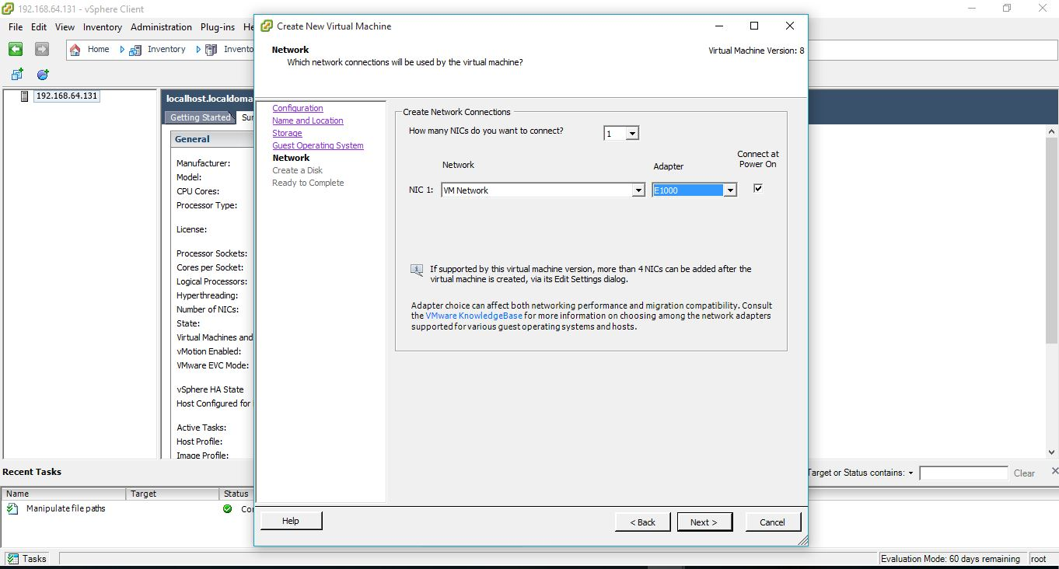

39. Create Disk as Thin Provision.

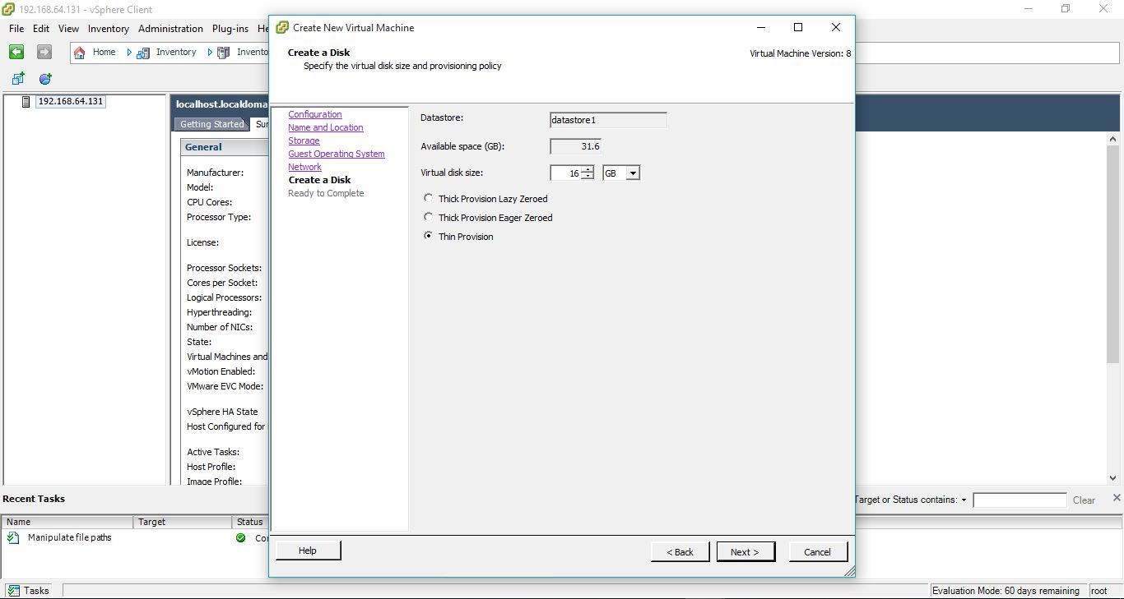

40. To complete press Finish.

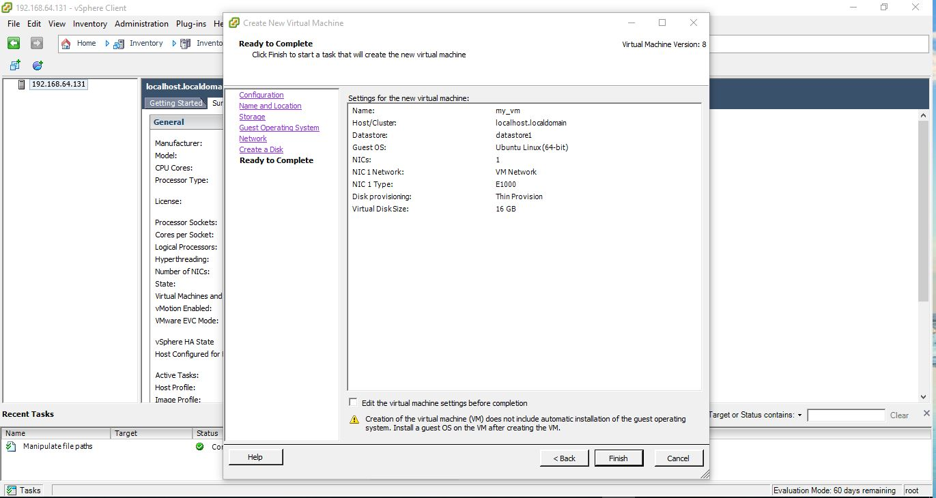

41. Power on the virtual machine.

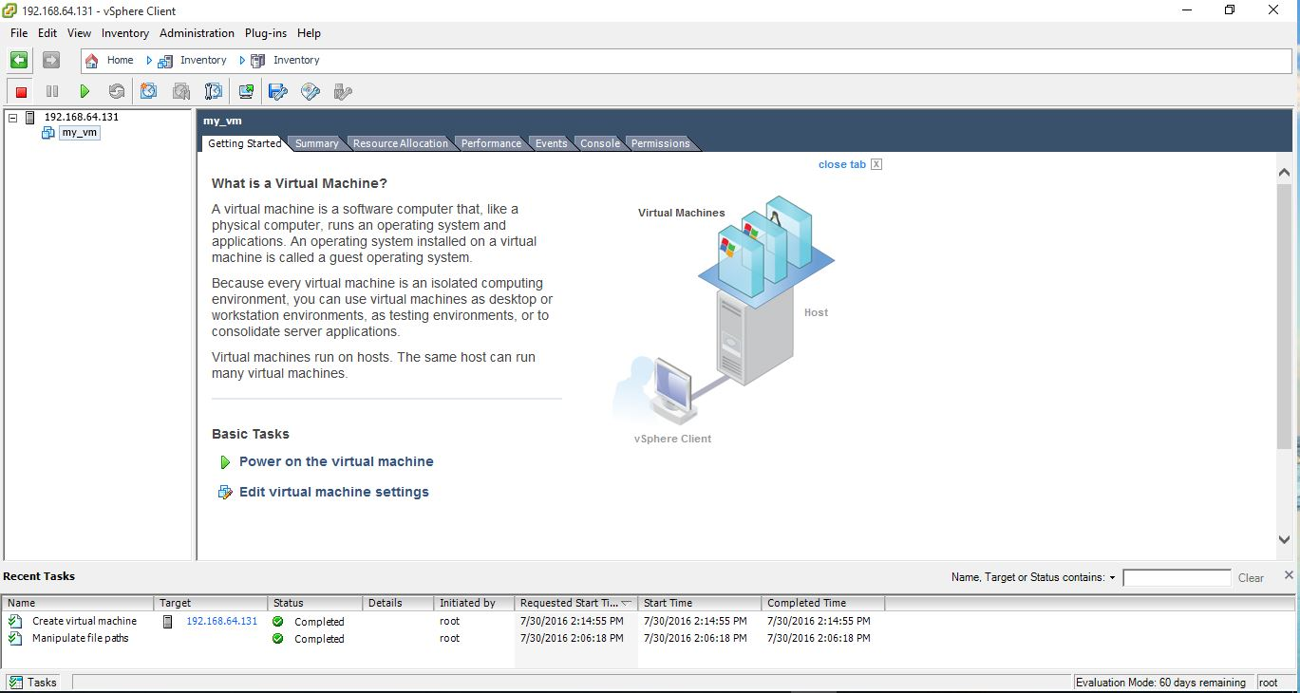

42. Right click on the created virtual machine (my_vm) and go to CD\DVD drive. Then choose Database ISO file and browse and give the previously created database.

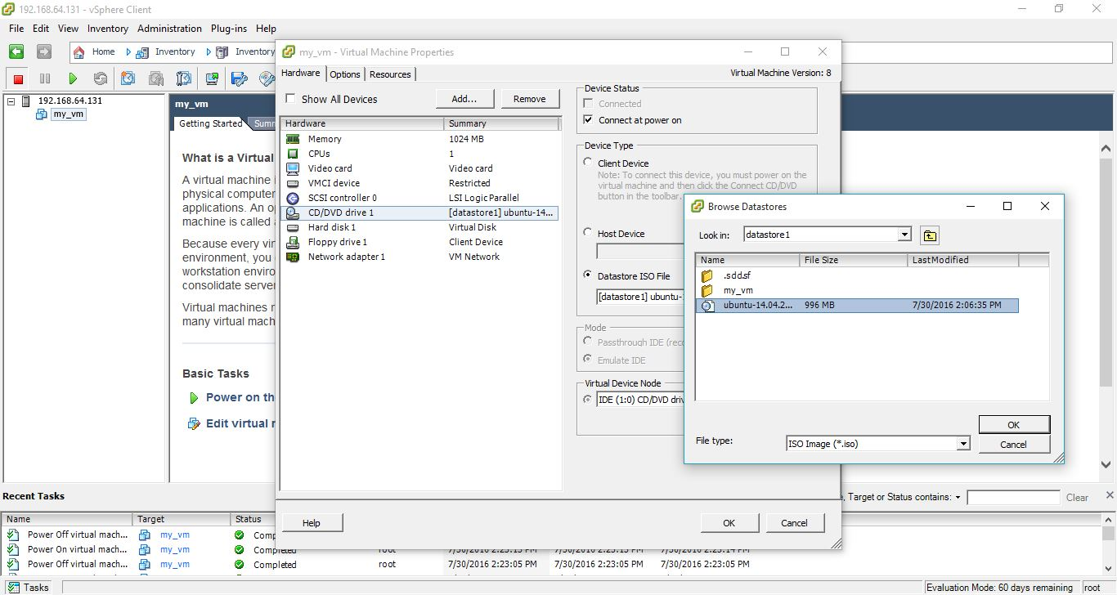

43. Go to console.

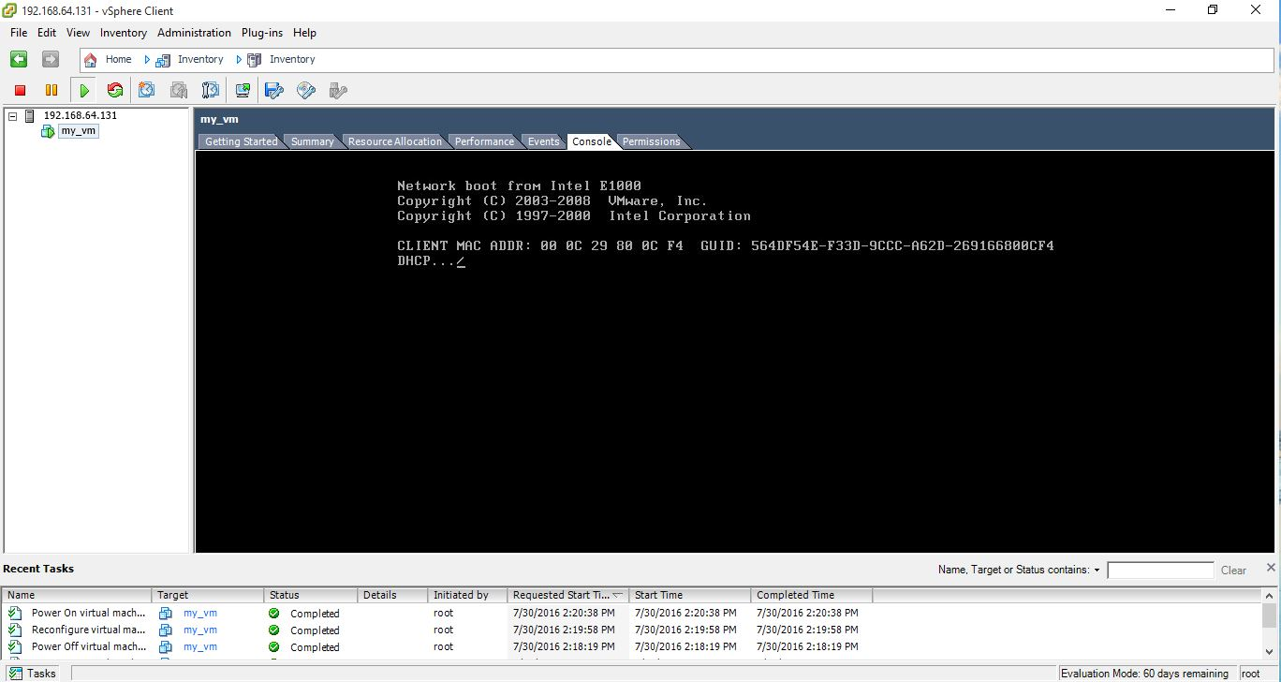

44. Installing the Ubuntu OS in the created virtual machine.

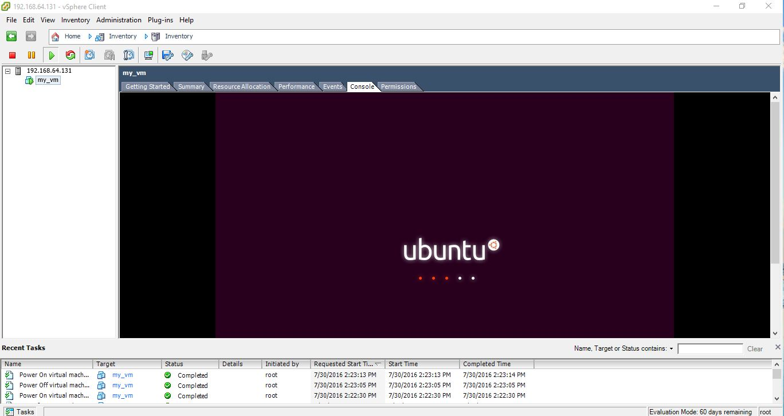

45. Now virtual machine is ready to work.

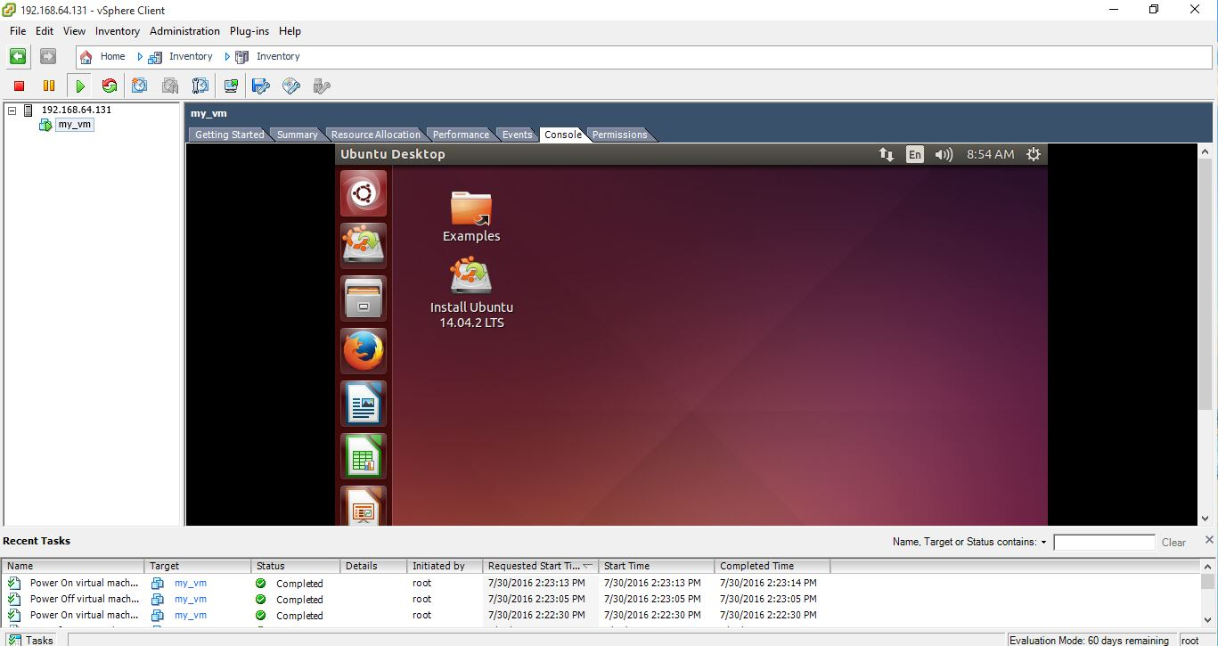

<https://github.com/dsreyhart/ESBPII_LabReport_4>